THE HISTORY OF HOPE CC

About a decade ago, a couple devoted to serve
the Lord decided to go back to their homeland.
They thought of planting a church in the heart
of the Philippine Islands where their roots are from.
The Panay mission humbly started from a small
home Bible study in Savannah Iloilo Subdivision.

Around January 2014, their hearts’ desire was partially
answered. With God’s abundant provision, a 566 sqm lot
located in the Municipality of Pavia in Iloilo Province was
acquired.

Pastor Godfrey and his wife, Gloria, then decided to build the new
church in this locality. They foresaw that many families would be brought closer to the Lord with the more than twenty new villages and subdivisions being developed around the locality.

God’s ministry continued as a church building was designed and constructed with the help of Pastor Godfrey’s nephew who was an architect. The design was not only a place of worship but also incorporated a library, an AV room, a pastor’s office, a small room for the Children’s ministry and spacious rooms to accommodate visiting ministers and their families. The construction started on September 2015.

Photo of groundbreaking

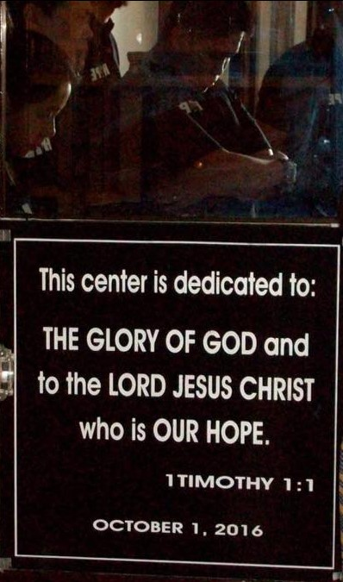

2016 Milestones - The CHURCH BUILDING was completed!

A small group started to gather in May and by July of 2016, worship services have begun. Indeed, the Lord brought some 20 families who regularly attend these church services.

By God’s overwhelming grace, on October 1, 2016, a time capsule was placed as a symbol of Hope Christian Church of Pavia, Inc humble beginnings. Thus, the first formal worship service was held on October 2, 2016, which also marks the October Anniversary month.

As a formal organization, it was duly registered under the Securities and Exchange Commission (SEC) as a non-profit non-stock organization by November22, 2017.
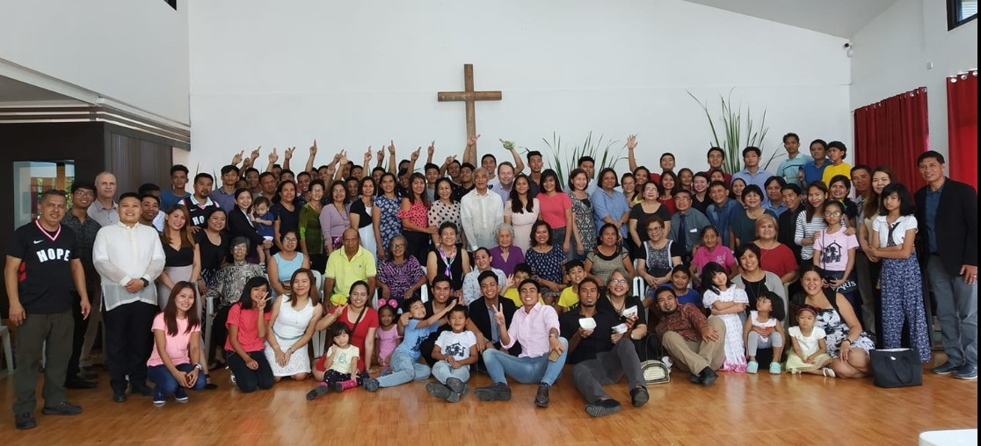

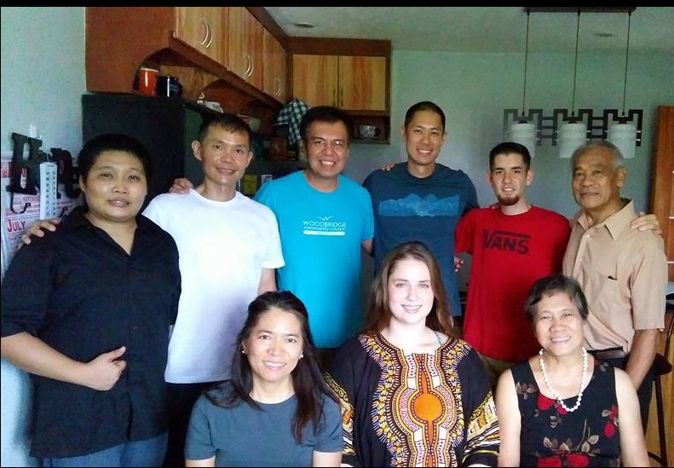

With the continuing support of HOPE CC’s partners here and abroad, the church ministry continues to grow. It has engaged the community with various avenues wherein the Gospel will be shared in every home: from the child, the youth, the parent, and to the grandparents.

Through the help of its core members, HOPE CC was also able to acquire the adjacent lot within Centro Verde Subdivision for future ministry use.
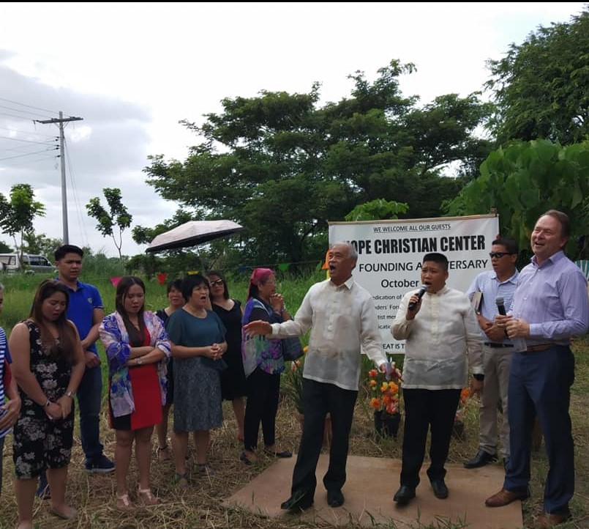

In spite of the pandemic brought about the
COVID-19 virus, the church continues to worship
and serve the Lord through various ministries:

- Home Bible Study

- Youth ReGEN: Basketball, Camps

- Art classes

- Early childhood Education

- Feeding Program

- Parenting Class

- Medical Mission

It continues to edify the body of believers through:

- Corporate Prayers
- Worship
- Baptism
- Bible Study for all ages
- Outreach in Panay Island’s rural areas
- Youth fellowship and
- Women’s monthly fellowship

Also a source of encouragement to the fellow ministry
workers in the field, HOPE CC also devoted itself to:

- Pastors’ Continuing Education
- Pastors and Wives’ Annual Appreciation
- Pastors Kids’ Retreat
- Pastor’s Assistance Program

To the regions and beyond, HOPE CC continuously
extends the Kingdom of God through the Hope
Community Radio in the city of Roxas, Capiz
Province.

At the same time, Church Planting and
Medical Missions are actively pursued in the
Municipality of Kalibo, Aklan Province.

All to God, be the glory!

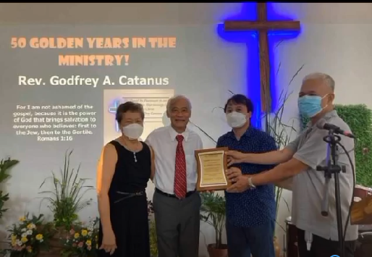

- “Being confident of this, that He who began a good work in you will carry it onto completion, until the day of Christ Jesus.”

- Philippians 1:6

